**EXP 1: Development and Deployment of a Cloud-Based SaaS Application Using Zoho Creator**

**DATE:** 13-02-25

**AIM:**  
The objective of this experiment is to develop a simple cloud-based application and illustrate the principles of Software as a Service (SaaS). This involves providing access to the software via the cloud, ensuring scalability, cost-effectiveness, and ease of accessibility for users.

**PROCEDURE:**

1. Navigate to [Zoho Creator](https://www.zoho.com/creator/) and log in to your account.
2. Select "Create New Application" and opt for "Create from Scratch."
3. Assign a name to the application and proceed to create it.
4. Click on "Create New Form" and provide an appropriate name for the form.
5. Add relevant fields to the form based on user requirements (e.g., Name, Email, Feedback, etc.).
6. Configure field properties, establish necessary workflows, and save the form.
7. Deploy the application by publishing it to the cloud for user accessibility.
8. Verify the deployment and test the application's functionality to ensure smooth operation.

**STEP1:**GO TO ZOHOCREATOR.COM AND LOGIN TO YOUR ACCOUNT

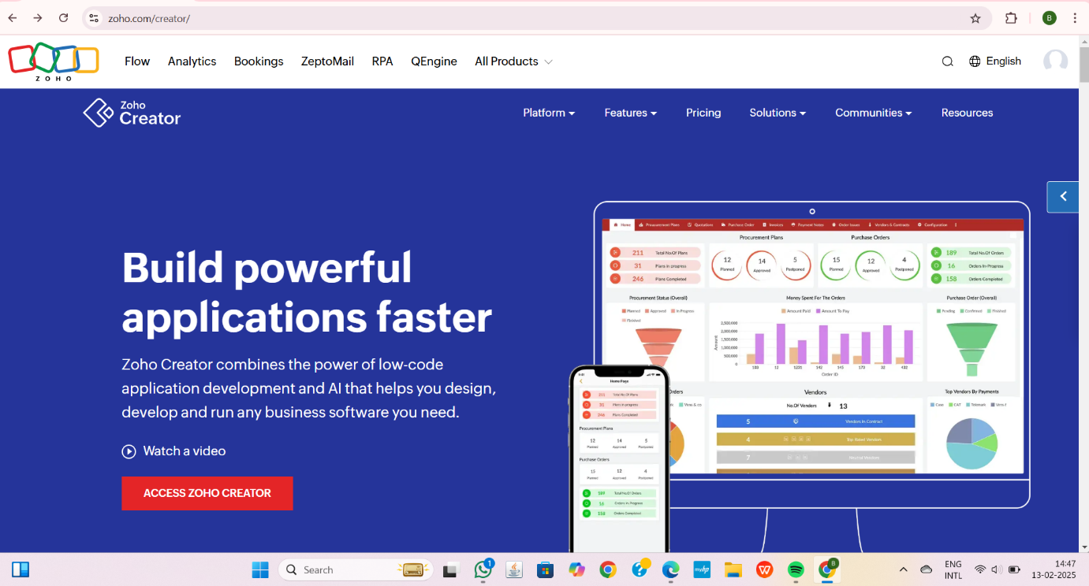

**STEP2:**CLICK CREATE NEW APPLICATION AND CREATE FROM SCRATCH

**STEP3:** ENTER APPLICATION NAME AND CREATE APPLICATION

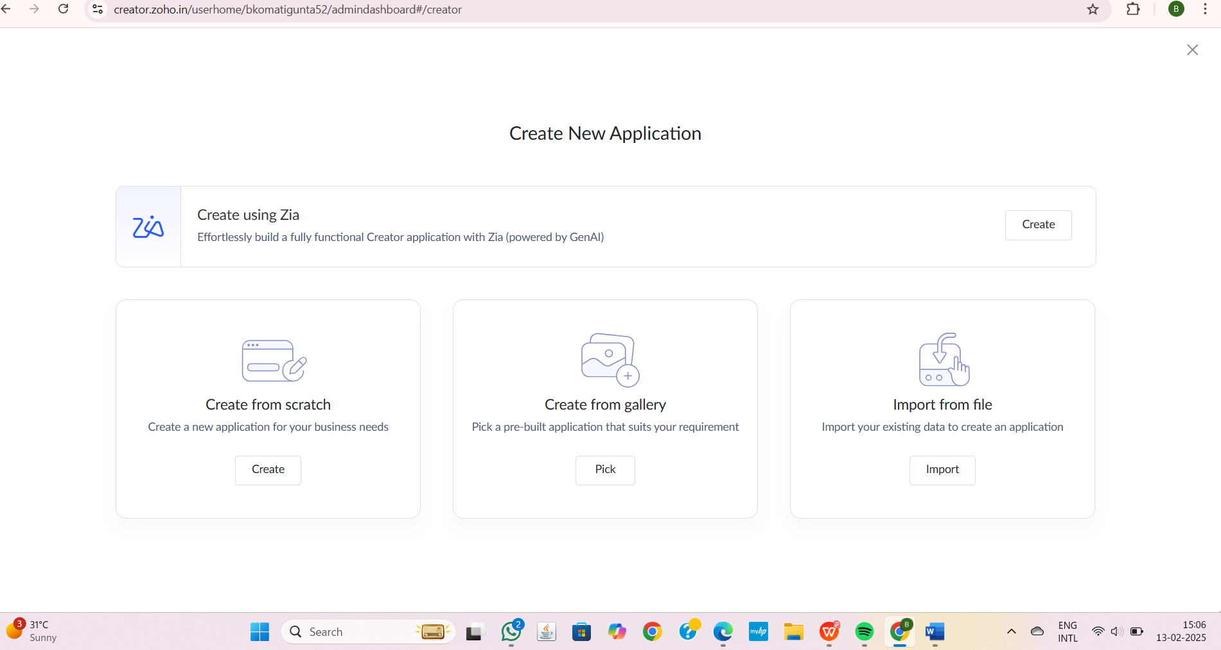

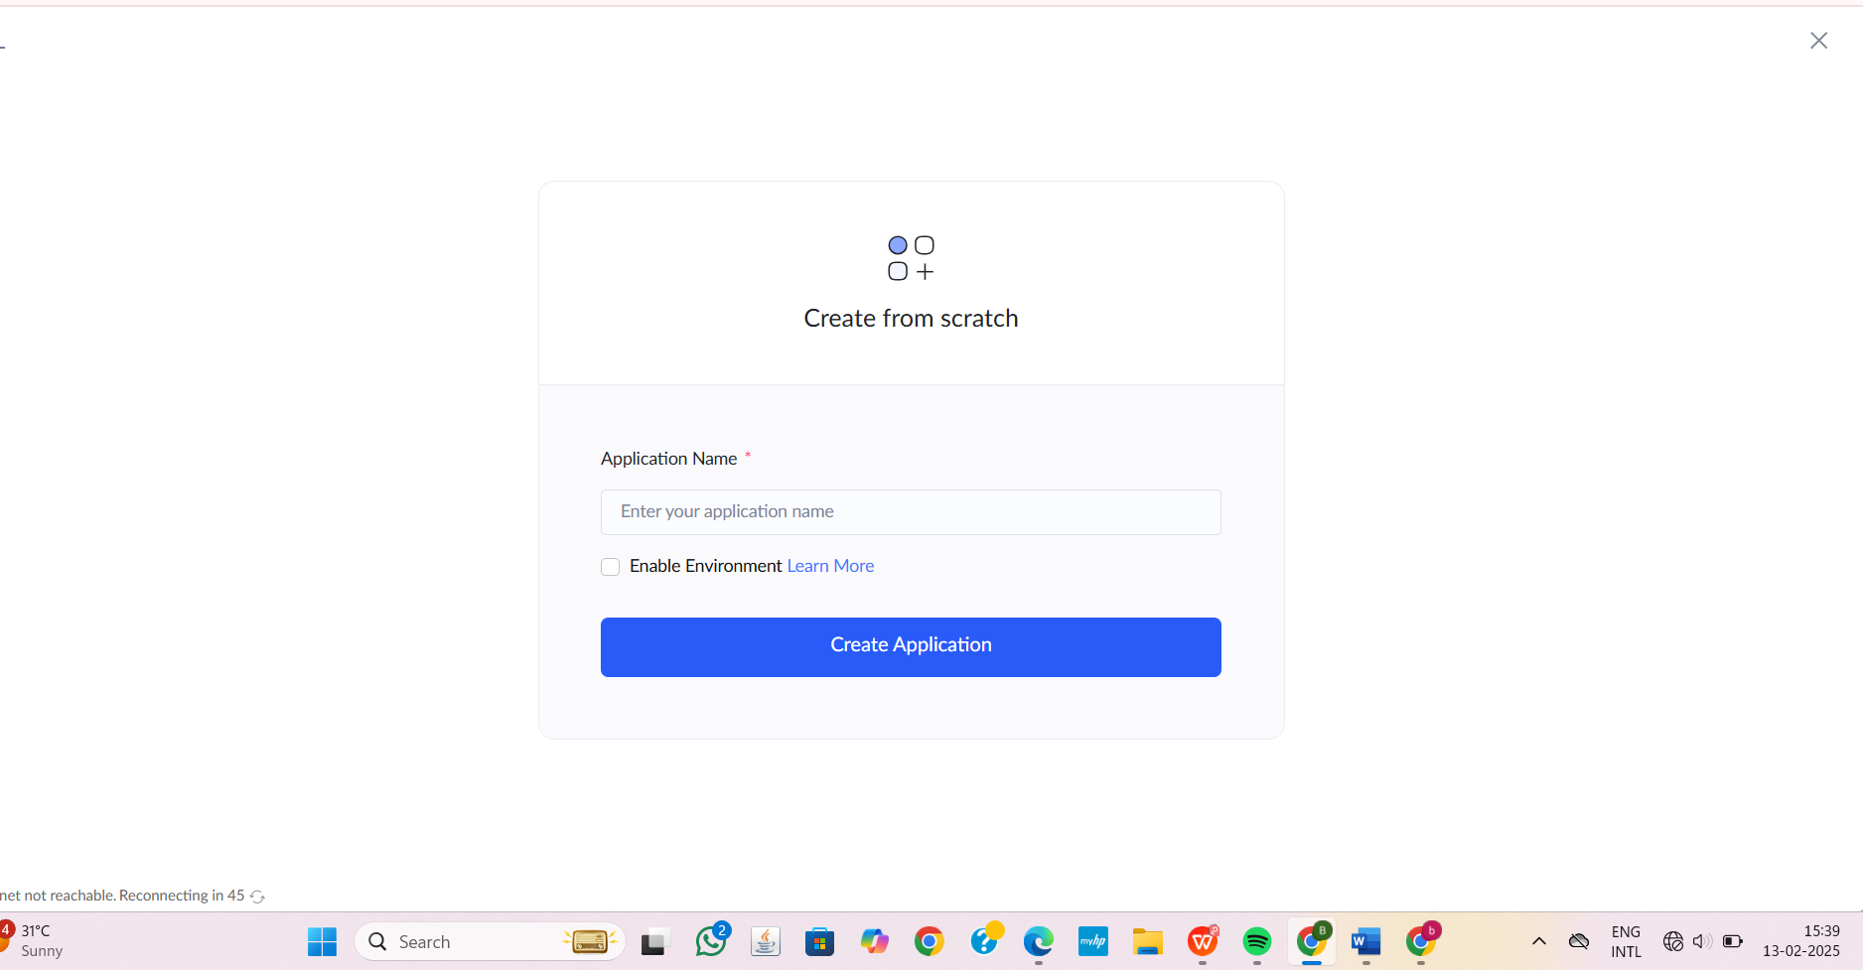

**STEP4:**CLICK ON CREATE NEW FORM AND NAME THE FORM

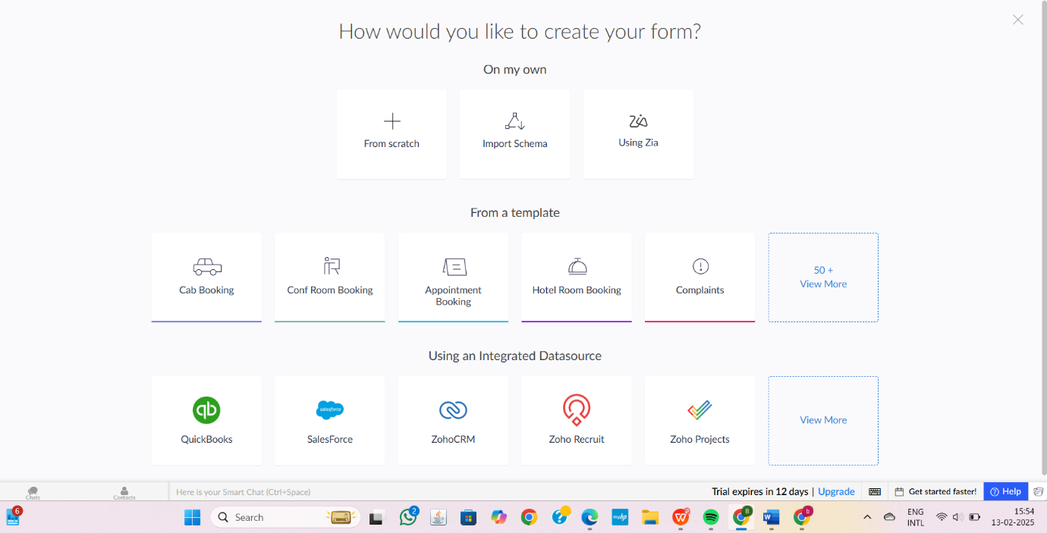

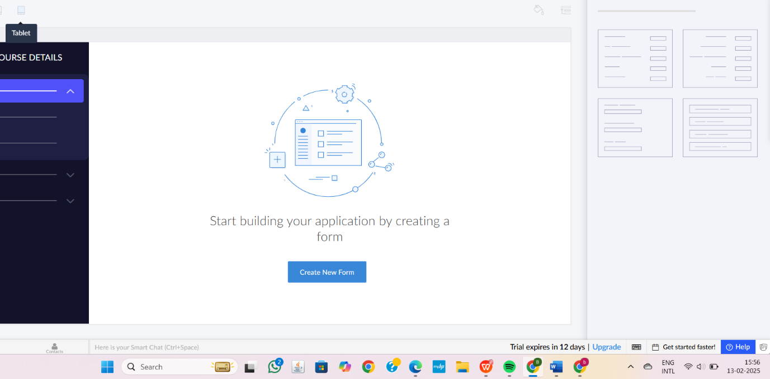

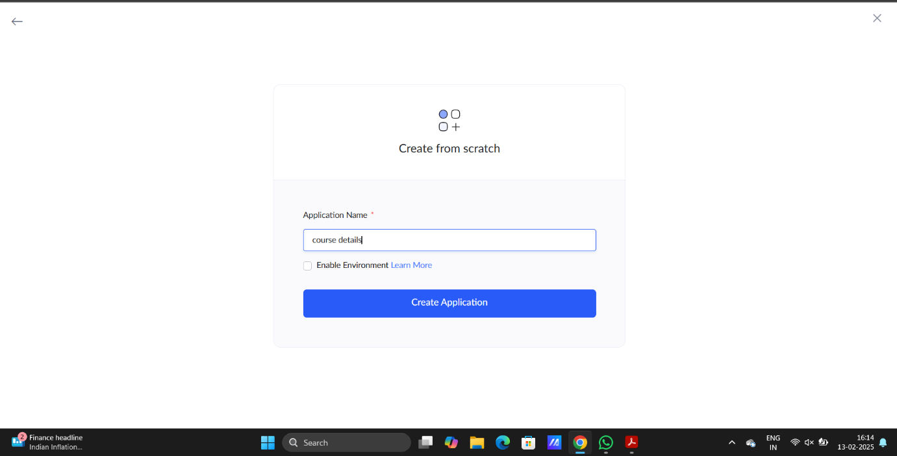

1.COURSE INFORMATION AND ITS DETAILS

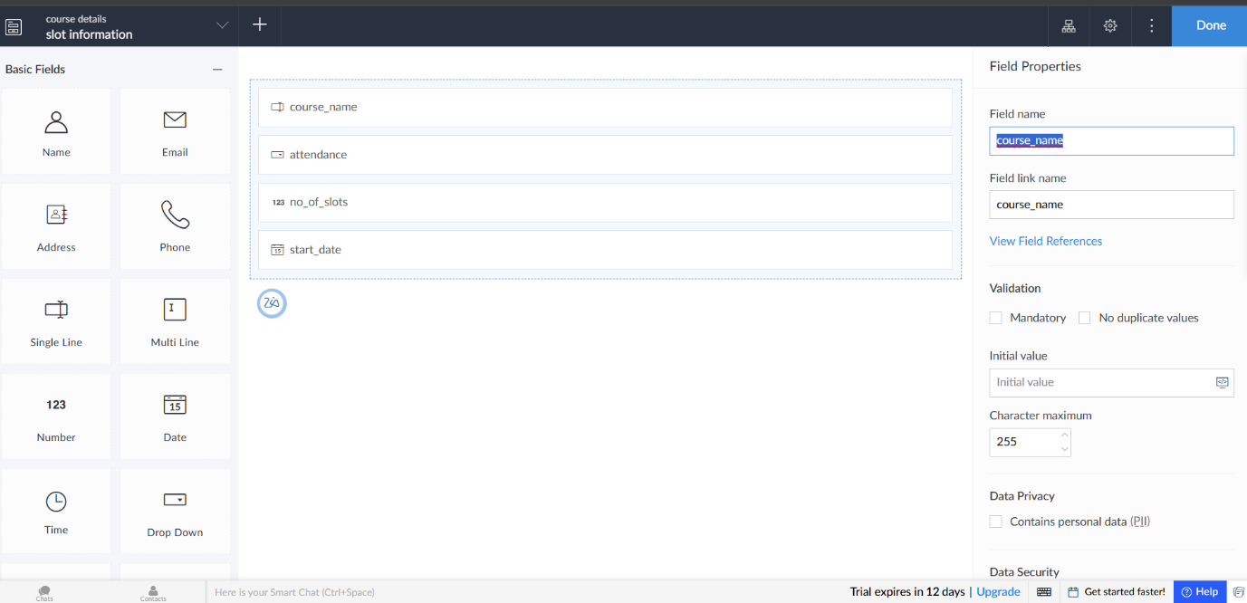

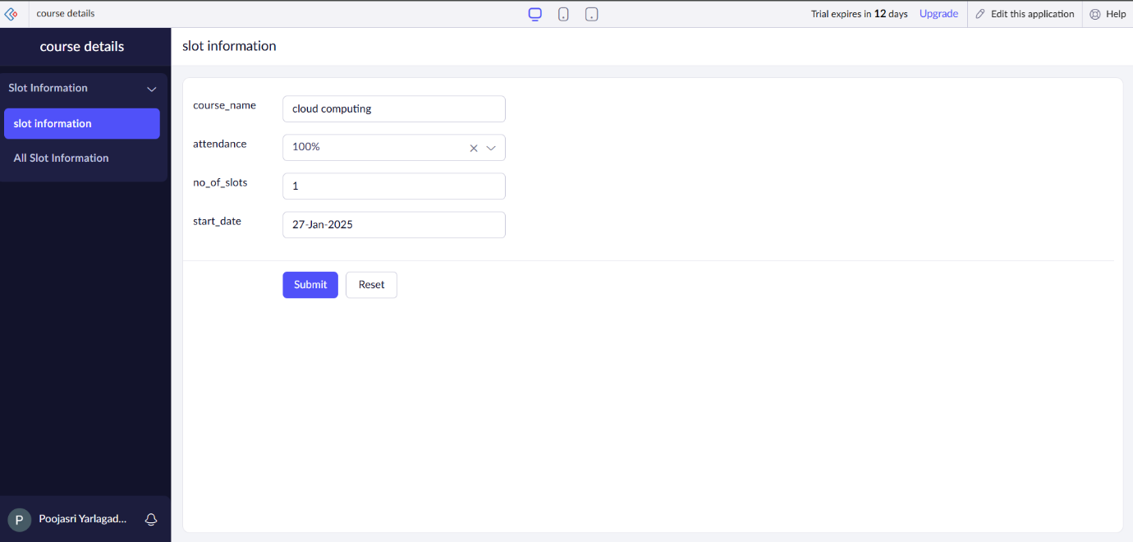

2.FACULTY INFORMATION AND ITS DETAILS

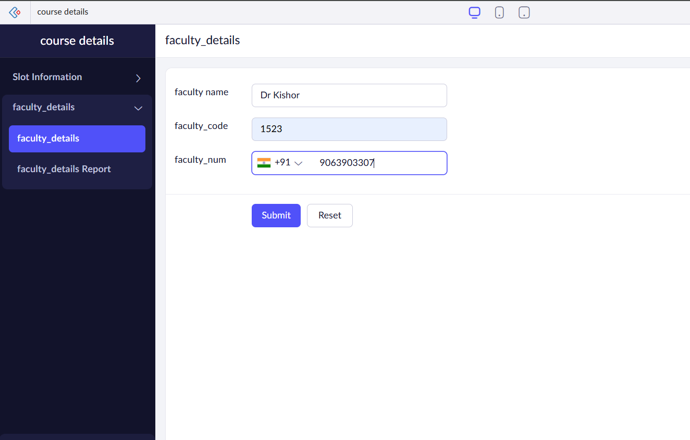

3.COURSE FEEDBACK

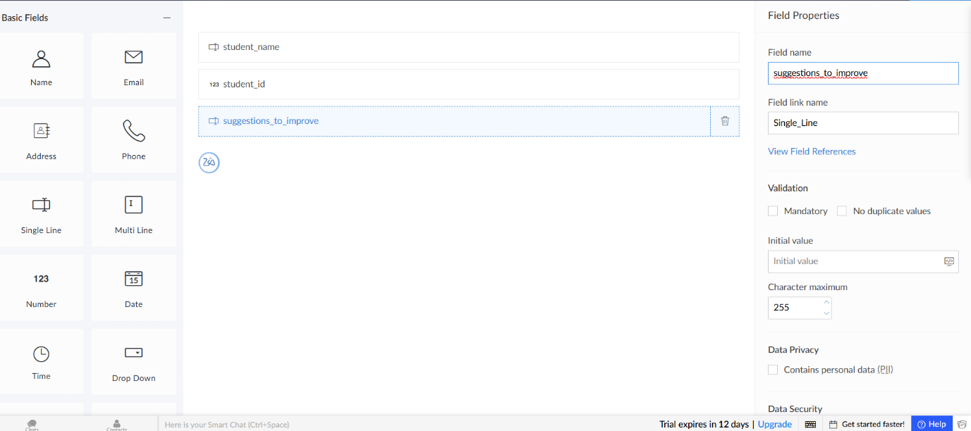

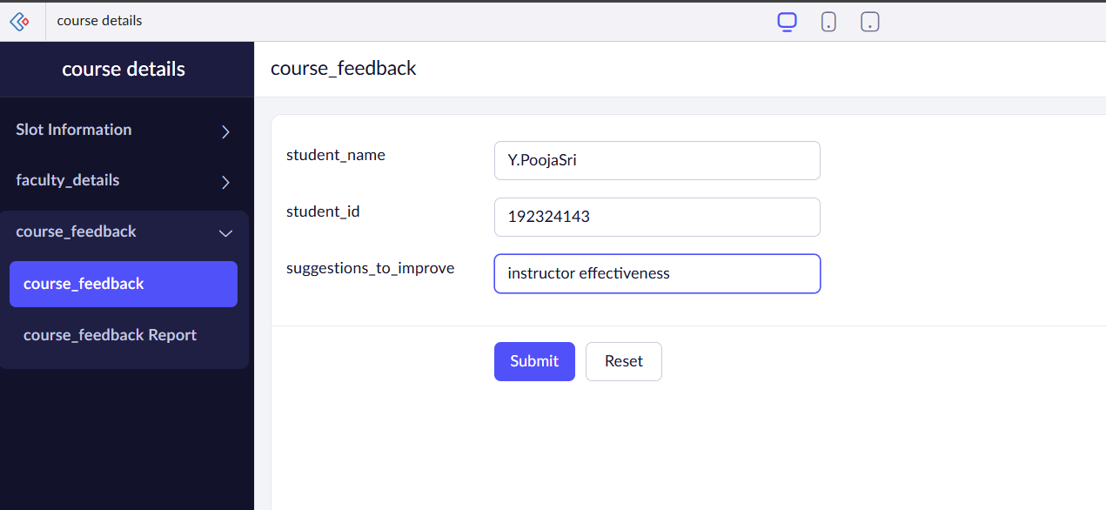

**STEP6:**THE SOFTWARE HAS BEEN CREATED.

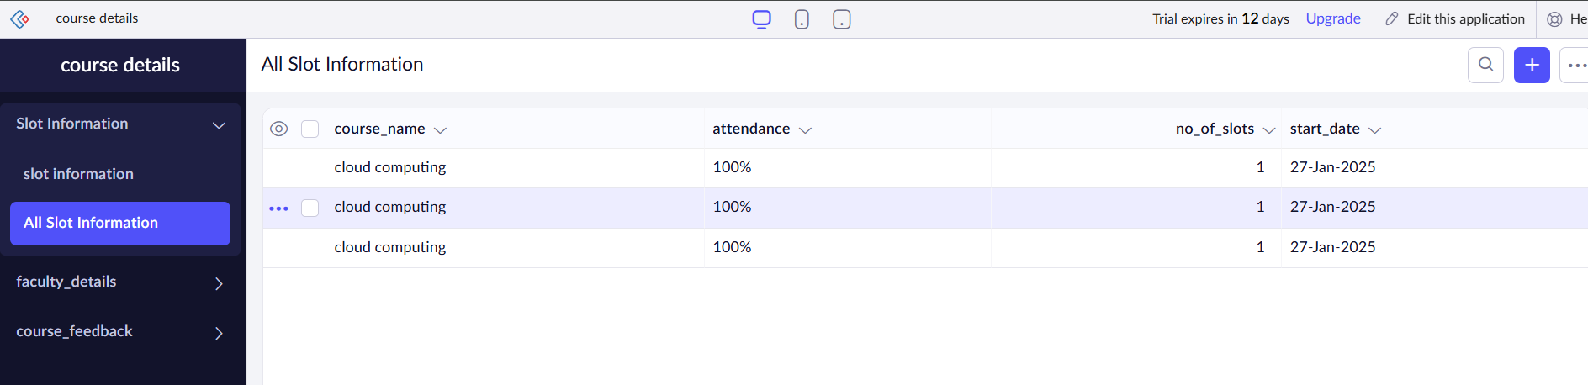

**EXP 2: Create a simple cloud software application for Flight Reservation System using any Cloud Service Provider to demonstrate SaaS**

**DATE:** 13-02-25

**AIM:**To develop a **Flight Reservation System** as a **Software as a Service (SaaS)** application using a cloud service provider, allowing users to book flights, manage reservations, and check flight availability in real-time. This project demonstrates the benefits of cloud-based SaaS, including scalability, accessibility, and cost efficiency.

**PROCEDURE:**

1. Choose a Cloud Service Provider
2. Define System Requirements
3. Develop Backend Services
4. Build Frontend Interface
5. Deploy on Cloud
6. Testing & Performance Optimization
7. Monitor & Scale
8. Test and Launch

STEP 1:GO TO ZOHO.COM AND LOGIN TO YOUR ACCOUNT



**STEP2:**CLICK CREATE NEW APPLICATION AND CREATE FROM SCRATCH

**STEP3:** ENTER APPLICATION NAME AND CREATE APPLICATION





**STEP4:**CLICK ON CREATE NEW FORM

**STEP 5:** NAME THE FORM





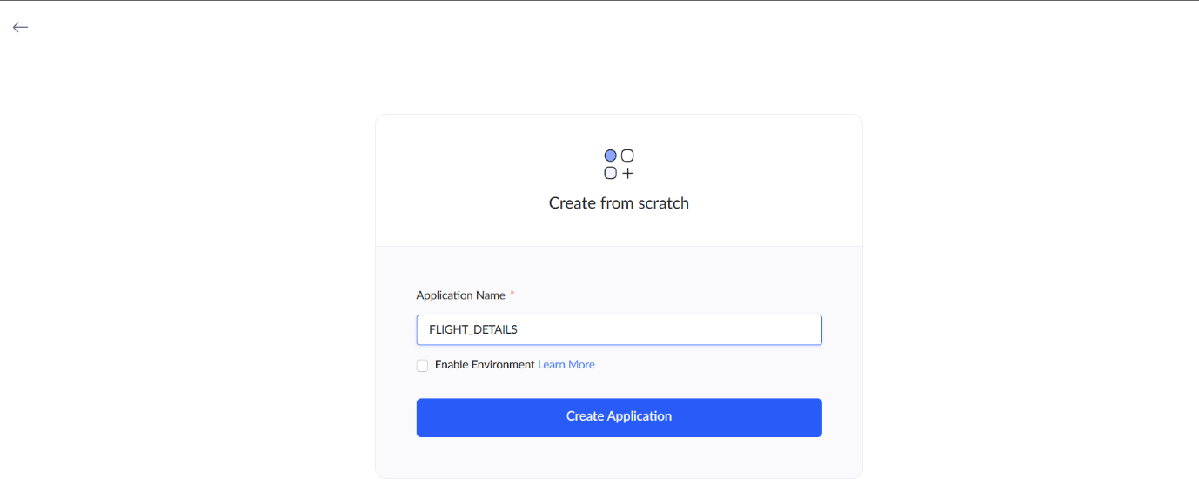

1.FLIGHT INFORMATION AND ITS DETAILS

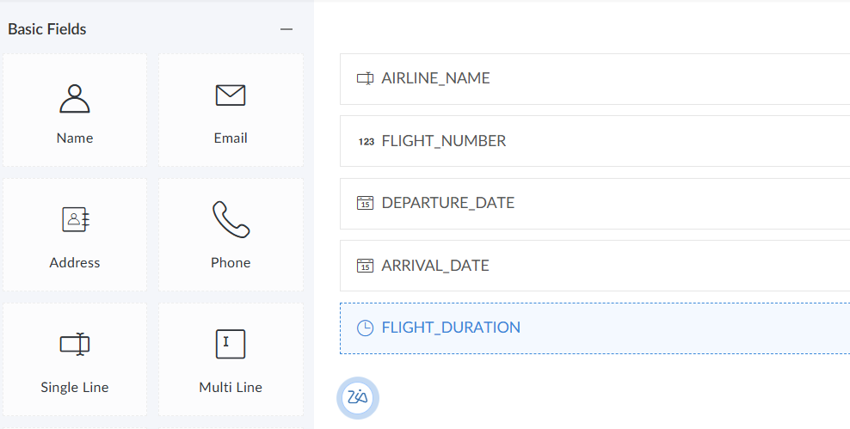

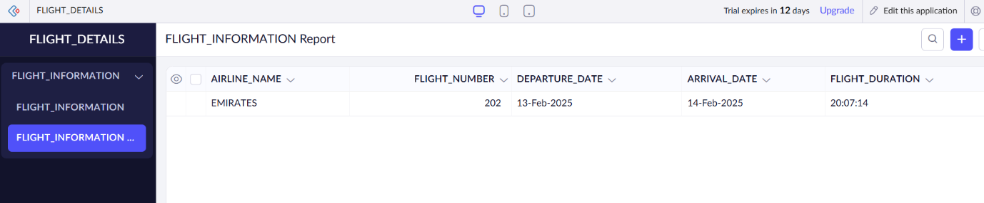

2.PASSENGER INFORMATION AND ITS DETAILS

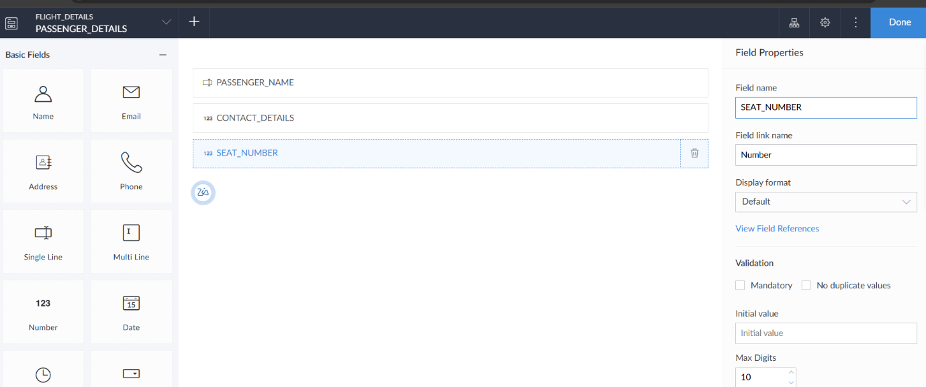

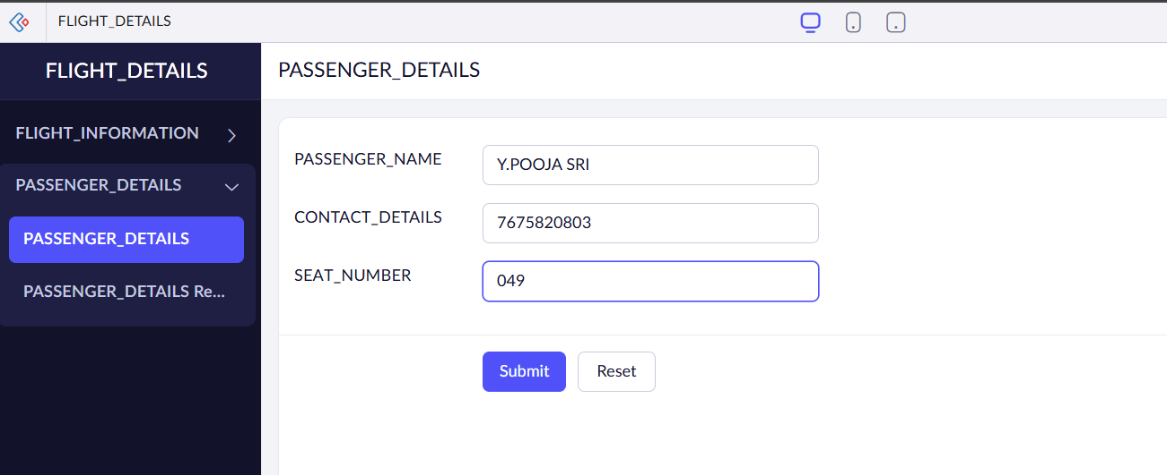

3.PAYMENT DETAILS

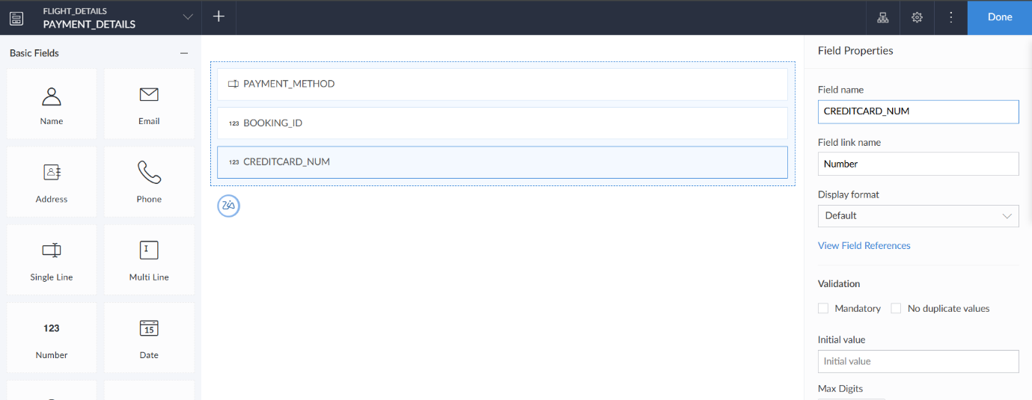

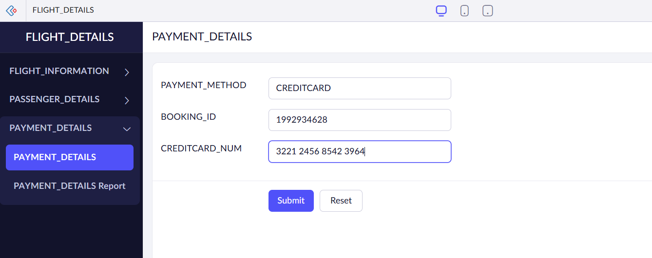

**STEP 6:**THE SOFTWARE HAS BEEN CREATED

